Start ECMListener Service

1. Start a Command Prompt as an Administrator and navigate to the bin/debug folder of ECMLIstener Application
2. Go to the folder containing the DirListen.exe
3. Run from the command line DirListen.exe Install
4. 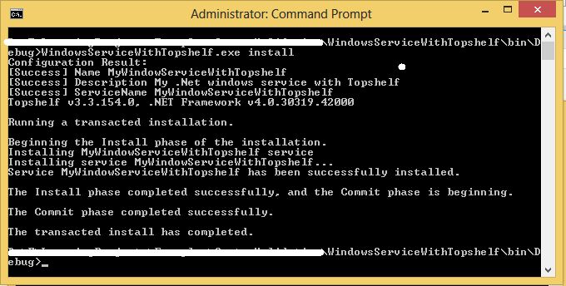
5. Open the task manager and for the first time, find and start the service.
   1. The service will restart automatically upon the machine rebooting after install.
6. To uninstall windows service run this command.
   1. However, the service can be stopped using the task manager
   2. The uninstall actually removes the service from the system
7. DirListen.exe Uninstall